# **INTRODUCTION**

NAME : ANSH RAJ

SECTION : H1

UNIVERSITY ROLL NO. 2218388

CLASS ROLL NO. 14

MINI PROJECT TOPIC : ERP SYSTEM

SUBMITTED TO : SONALI MA’AM

# **TABLE OF FIGURES**

|  |  |  |
| --- | --- | --- |
| **Figure No.** | **Figure Name** | **Page No.** |
| 4.1 | Account table description | 9 |
| 4.2 | Student table description | 9 |
| 4.3 | Teacher table description | 10 |
| 4.4 | Attendance\_student table description | 10 |
| 4.5 | Attendance\_teacher table description | 10 |
| 4.6 | Subject table description | 11 |
| 4.7 | Marks table description | 11 |
| 4.8 | Fee table description | 12 |
| 6.1 | Login Page | 17 |
| 6.2 | Signup Page | 17 |
| 6.3 | Home Page | 18 |
| 6.4 | Student Page | 18 |
| 6.5 | Teacher Page | 18 |
| 6.6 | Subject Page | 19 |
| 6.7 | Fee Page | 19 |

# **LIST OF TABLES**

|  |  |  |
| --- | --- | --- |
| **TABLE NO.** | **DESCRIPTION** | **PAGE NO.** |
| 1.1 | Account Table | 13 |
| 1.2 | Student Table | 13 |
| 1.3 | Teacher Table | 14 |
| 1.4 | Attendance\_Student Table | 14 |
| 1.5 | Attendance\_Teacher Table | 15 |
| 1.6 | Subject Table | 15 |
| 1.7 | Marks Table | 16 |
| 1.8 | Fee Table | 16 |

# **CHAPTER 1**

INTRODUCTION

# **1.1 Overview:**

Enterprise Resource Planning is a flagship product of Easy Solution which covers all aspects of Universities, Colleges, Schools, Businesses etc. ERP covers every minute aspects of a universities work flow and integrates all processes with user friendly interface. With hundreds of satisfied customers ERP is first choice of several state, governments/semi- government universities and institutions. ERP is an outcome of hard work done by our expert technical team in supervision of several renowned educationists which includes Controller of examination, faculties. ERP streamline path of information flow in organization by taking care of following departments:

* + - Fee Department
    - Examination Department
    - Attendance
    - Faculty information portal
    - Student information portal

## **Purpose:**

* + - Drive operational efficiency.
    - Self-service systems with simple to use with little or no training.
    - Elimination of duplicate data entry processes.
    - Integrated with Online Application workflow with unified data model.
    - Monitoring and decision support system.
    - Automation of all the Academic / Examination / Administration operations.
    - Ease and accuracy of reporting.

### **1.3 Scope:**

This project deals with the various functioning in College management process. The main idea is to implement a proper process to system. In my existing system contains a many operations registration, student search, fees, attendance, exam records, performance of the student etc. All these activity takeout manually by administrator.

# **CHAPTER 2**

REQUIREMENT SPECIFICATIONS (MIN)

## **Hardware Requirements :**

|  |  |
| --- | --- |
| Processor Brand | : Intel |
| Processor Type | : Core i3 |
| Processor Speed | : 2 GHz |
| Processor Count | : 1 |
| RAM Size | : 2 GB |
| Memory Technology | : DDR3 |
| Computer Memory Type | : DDR3 SDRAM |
| Hard Drive Size | : 160 GB |

* 1. **Software Requirements :**

Operating system : Windows 10

Application server : JAVA (NetBeans)

Front end : JAVA

Connectivity : JDBC Driver

Database connectivity : WAMP (MYSQL Console)

# **CHAPTER 3**

TOOL DESCRIPTION

## **Overview of Front End**

An important issue for the development of a project is the selection of suitable front- end and back-end. When I decided to develop the project I went through an extensive study to determine the most suitable platform that suits the needs of the organization as well as helps in development of the project.

The aspects of our study included the following factors. Front-end selection:

1. It must have a graphical user interface that assists employees that are not from IT background.
2. Scalability and extensibility.
3. Flexibility.
4. Robustness.
5. According to the organization requirement and the culture.
6. Must provide excellent reporting features with good printing support.
7. Platform independent.
8. Easy to debug and maintain.
9. Event driven programming facility.
10. Front end must support some popular back end like MySQL.

.

### **About Java:**

Java is a general-purpose, class-based, object-oriented programming language designed for having lesser implementation dependencies. It is a computing platform for application development. Java is fast, secure, and reliable, therefore. It is widely used for developing Java applications in laptops, data centers, game consoles, scientific supercomputers, cell phones, etc.

Here are some important Java applications:

* + - * It is used for developing Android Apps
      * Helps you to create Enterprise Software
      * Wide range of Mobile java Applications
      * Scientific Computing Applications
      * Use for Big Data Analytics
      * Java Programming of Hardware devices
      * Used for Server-Side Technologies like Apache, JBoss, GlassFish, etc.

## **Overview of Back End**

Back End Selection:

1. Multiple user support.
2. Efficient data handling.
3. Provide inherent features for security.
4. Efficient data retrieval and maintenance.
5. Stored procedures.
6. Popularity.
7. Operating System compatible.
8. Easy to install.
9. Various drivers must be available.
10. Easy to implant with the Front-end.

According to above stated features we selected MySQL as the backend.

The technical feasibility is frequently the most difficult area encountered at this stage. It is essential that the process of analysis and definition be conducted in parallel with an assessment to technical feasibility. It centers on the existing computer system (hardware, software etc.) and to what extent it can support the proposed system.

### **About SQL:**

SQL is Structured Query Language, which is a computer language for storing, manipulating and retrieving data stored in a relational database.

SQL is the standard language for Relational Database System. All the Relational Database Management Systems (RDMS) like MySQL, MS Access, Oracle, Sybase, Informix, Postgres and SQL Server use SQL as their standard database language.

MySQL is a fast, easy-to-use RDBMS being used for many small and big businesses. MySQL is developed, marketed and supported by MySQL AB, which is a Swedish company. MySQL is becoming so popular because of many good reasons.[1]

MySQL is released under an open-source license. So you have nothing to pay to use it. MySQL is a very powerful program in its own right. It handles a large subset of the functionality of the most expensive and powerful database packages. MySQL uses a standard form of the well-known SQL data language. MySQL works on many operating systems and with many languages including PHP, PERL, C, C++, JAVA, etc.

MySQL works very quickly and works well even with large data sets. MySQL is very friendly to PHP, the most appreciated language for web development. MySQL supports large databases, up to 50 million rows or more in a table. The default file size limit for a table is 4GB, but you can increase this (if your operating system can handle it) to a theoretical limit of 8 million terabytes (TB).

Also, they are using different dialects, such as −

* Oracle using PL/SQL,.
* SQL is widely popular because it offers the following advantages −
* Allows users to access data in the database management systems.
* Allows users to describe the data.relational
* Allows users to define the data in a database and manipulate that data.
* Allows to embed within other languages using SQL modules, libraries & pre-compilers.
* Allows users to create and drop databases and tables.
* Allows users to create view, stored procedure, functions in a database.
* Allows users to set permissions on tables, procedures and views.

# **CHAPTER 4**

TABLE DESCRIPTION

## **4.1 Database Design**

**Account Table**: Account table consists of five attributes which are Username, Name, Password, Sec\_ques, Sec\_ans.Username is used as Primary key.

Desc account;

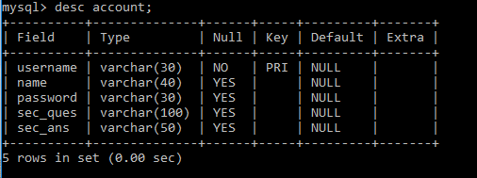

### Fig 4.1 Account table description

**Student table :**Student table is used to add the details of new student like Name,phoneno.,DoB,course,Branch etc...Phoneno. ,E-mail and Aadhar are used as Primary key.

Desc student;

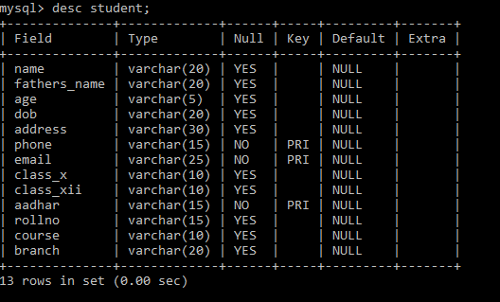

### Fig 4.2 Student table description.

**Teacher table:** Teacher table is used to add the details of new student like Name, phoneno.,DoB, course,Branch etc...Phoneno. ,E-mail and Aadhar are used as Primary key.

Desc teacher;

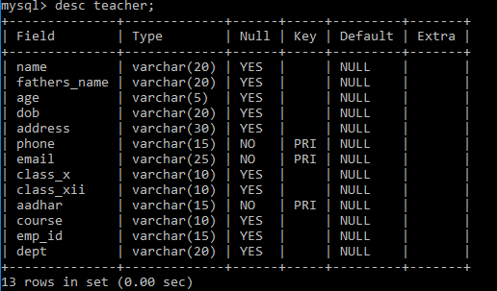

### Fig 4.3 Teacher table description

**Attendance\_Student Table:** Attendance\_Student table is used to mark the attendance of the student day to day which as attributes like rollno,name,first and second half.

Desc attendance\_student;

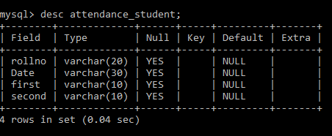

### Fig 4.4 Attendance\_Student table description.

**Attendance\_Teachertable :**Attendance\_Teacher table is used to mark the attendance of the teacher day to day which as attributes like emp\_id,name,first and second half.

Desc attendance\_teacher;

### Fig 4.5 Attendance\_Teacher table description.

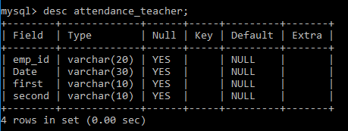

**Subject table :**Subject table is used to add the subjects of the student in that particular sem with the attributes like rollno and five subjects.

Desc Subject;

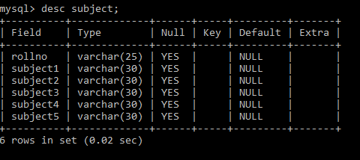

### Fig 4.6 Subject table description

**Marks table :**Marks table is used to add the marks of the particular subjects of the student in a particular sem and the attributes used are rollno and five subject marks.

Desc Marks;

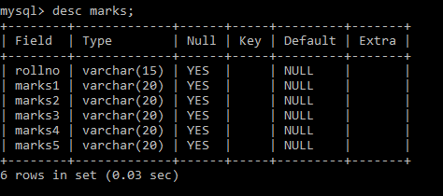

### Fig 4.7 Marks table description.

**Fee table:**fee table is used to pay the fee dues of the student for that particular sem and the attributes used like rollno, name, fathersname, course, branch, sem and fee\_paid.

Desc Fee;

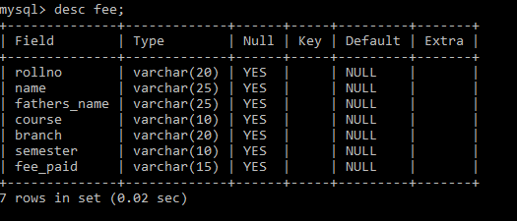

### Fig 4.8 Fee table description.

# **CHAPTER 5**

TABLE WITH VALUES

## **5.1 Output design:**

**Account table :**Account table consists of five attributes which will be retrived from user when the user signsup/logs in.

Select \* from account;

### E:\dbms pics\Saved Pictures\mysql_selectaccount.PNGTable 1.1 Account table

**Student table:** Student table is used to add the details of new student like Name,phoneno.,DoB,course,Branch etc...Phoneno.E-mail and Aadhar are used as Primary key.

Select \* from student;

### Table 1.2 Student table

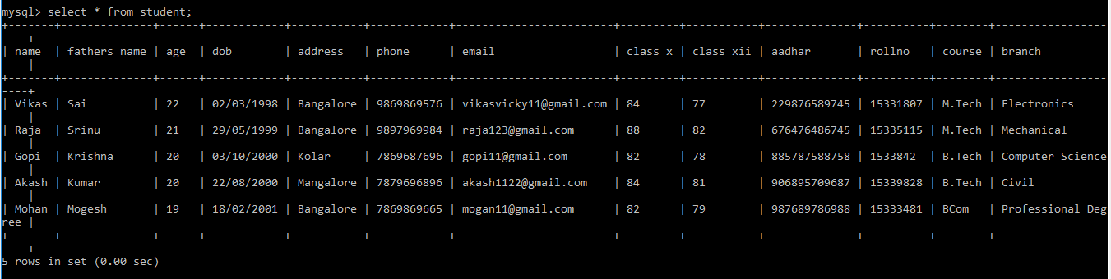

**Teacher table :**Teacher table is used to add the details of new student like Name,phoneno.,DoB,course,Branch etc...Phoneno. ,E-mail and Aadhar are used as Primary key.

Select \* from teacher;

### Table 1.3 Teacher table

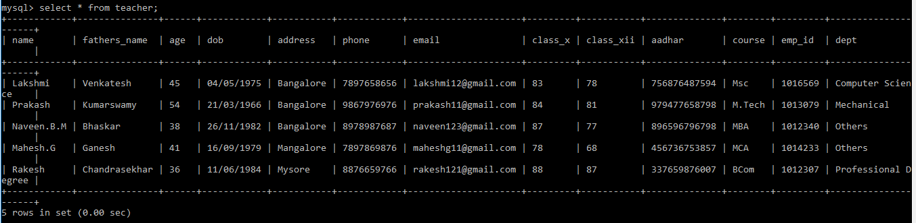

**Attendance\_Student table :**Attendance\_Student table is used to mark the attendance of the student day to day which as attributes like rollno,name,first and second half.

Select \* from attendance\_student;

### Table 1.4 Attendance\_student table

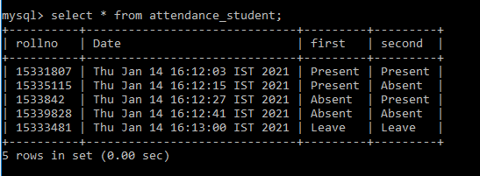

**Attendance\_Teacher table :**Attendance\_Teachertable is used to mark the attendance of the teacher day to day which as attributes like emp\_id,name,first and second half.

Select \* fromattendance\_teacher;

### Table 1.5 Attendance\_teacher table

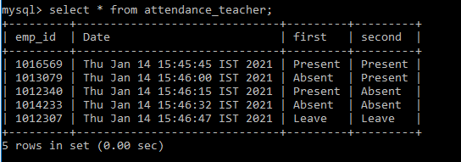

**Subject table :** Subject table is used to add thesubjects of the student in that particular sem with the attributes like rollno and five subjects.

Select \* from Subject;

### Table 1.6 Subject table

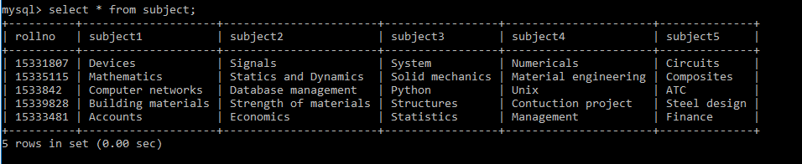

**Marks table :**Markstable is used to add the marks of the particular subjects of the student in a particular sem and the attributes used are rollno and five subject marks.

Select \* from Marks;

### Table 1.7 Marks table

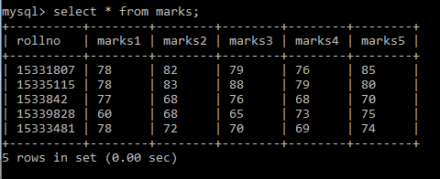

**Fee table :**fee table is used to pay the fee dues of the student for that particular sem and the attributes used like rollno, name, fathersname, course, branch, sem and fee\_paid.

Select \* from Fee;

**Table 1.8 Fee table**

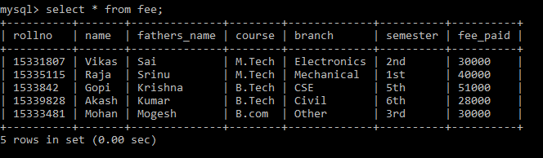

# **CHAPTER 6**

SNAPSHOTS

1. **Login form:** This page represents the first thing about our website. It leads on to the login point for its personnel; it takes up the username,password and signup.

### Figure 6.1: Login form

1. **Signup page:** This page represents signing up to website. It leads to registering to website making username and password, it takes the up username, name, password and security question. These information are mandatory.

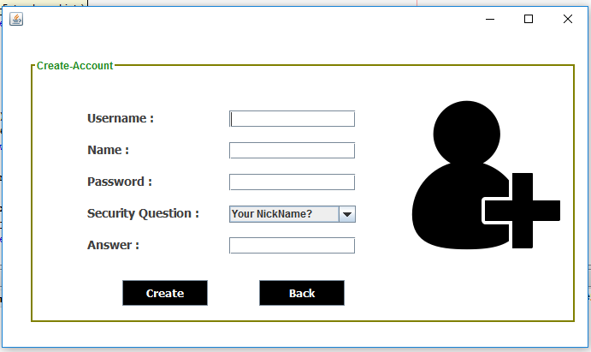

### Figure 6.2: Signup page

**3.Home page user :** This page shows us what user can see and access. He can add, remove,update and upload the data. He can logout from the website in homepage.

### Figure 6.3: Home page user

**4.Student form :** In this we can add the new student details which will be stored in back end of user.This details further can updated in the update page.

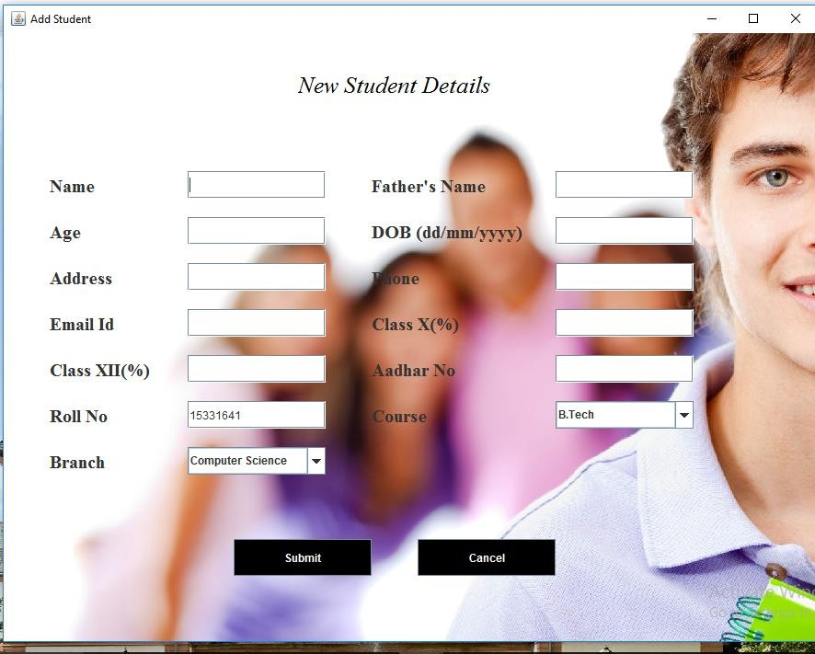

### Figure 6.4: Student form

**5.Teacher form:** In this we can add the new teacher details which will be stored in back end of user.This details further can updated in the update page.

### E:\dbms pics\Saved Pictures\java_newteacher.PNG Figure 6.5: Teacher form

**6.Marks and Subject page :** In this page we can enter the subjects and marks scored in that particular subject along the rollno.

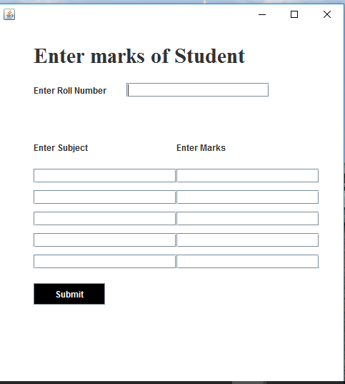

### Figure 6.6: Marks and Subject page

**7.Fee payment page :** In this page we can the pay the fee dues of the particular student which uses rollno,course,branch and sem to pay the fee.

### E:\dbms pics\Saved Pictures\java_fee.PNGFigure 6.7 : Fee Payment Page

# **CONCLUSION**

The project entitled as **ERP System for institution** is the system that deals with the issues related to a particular institution.

This project is successfully implemented with all the features mentioned in system requirement specifications.

The application provides appropriate information to users according to the chosen service.

The project is designed keeping in view the day to day problems faced by a college.

Deployment of this application will certainly help the college to reduce unnecessary wastage of time in personally going to each department for some information.

Awareness and right information about any college is essential for both the development of student as well as faculty. So this serves the right purpose in achieving the desired requirements of both the communities.